Department of Computer Engineering and Informatics
Middlesex University Dubai

CST4245 Data Visualisation, Computer Vision and Imaging
Coursework 1 - Report

Exploring Global Cardiometabolic Inequality Through Visual Analytics
Name: Muhammad Siraj Bilal
MISIS: M00848704
Supervisor name: Sudhakar Camilos Fernando
Faculty of Science and Technology

MSc Data Science & AI
March 2026
Table of Contents
Abstract 4
1. Introduction 5
1.1 Background and Context 5
1.2 Aim of the Report 5
1.3 Analytical Scope 5
1.4 Structure of the Report 6
2. Data and Data Preparation 6
2.1 Original Dataset 6
2.2 Added External Datasets 7
2.3 Dataset Type, Data Types, and Attribute Types 7
2.4 Data Cleaning and Harmonisation 8
2.5 Merging and Enrichment Process 9
2.6 Filtering, Derived Measures, and Final Master Dataset Structure 10
2.7 Missing Values and Limitations 10
2.8 Analytical Environment 11
3. Analytical Framing 11
3.1 Analytical Context 11
3.2 Analysis Questions 12
3.3 Why These Attributes and Questions Matter 13
4. Visual Design Strategy 13
4.1 Design Goals and Narrative Approach 13
4.2 Visual Marks and Encoding Choices 14
4.3 Chart Selection Rationale 14
4.4 Interactivity and Dashboard Logic 15
4.5 Accessibility and Readability 15
5. Analysis and Findings 16
5.1 Overall Burden and Broad Patterns 16
5.1.1 Global trend of cardiometabolic risk indicators 16
5.1.2 Top 15 countries by prevalence 17
5.1.3 Country level prevalence trajectories over time 19
5.2 Sex Based Differences 22
5.2.1 Sex differences across indicators over time 22
5.2.2 Gender gap in prevalence across countries 24
5.3 Regional and Income Inequalities 26
5.3.1 Regional patterns over time 26
5.3.2 Distribution by income group and sex 28
5.3.3 Income group patterns over time 29
5.3.4 Regional ranking over time 31
5.4 Socioeconomic Relationships and Explanatory Context 33
5.4.1 Economic development and cardiometabolic risk 33
5.4.2 Urbanisation and obesity 34
5.4.3 Ageing population and raised blood pressure 36
5.4.4 Urbanisation, obesity, & gender patterns across selected countries 37
5.4.5 Economic development, ageing, and cardiometabolic risk 39
5.4.6 Health expenditure, prevalence, and sex differences 40
5.4.7 Correlation between cardiometabolic risk and socioeconomic factors 42
5.4.8 Countries with the fastest rise in prevalence 44
6. Dashboard Discussion 47
6.1 Dashboard Purpose and Structure 48
6.2 Interaction and Filtering 48
6.3 From the Altair Dashboard to the Final Dash Dashboard 49
6.4 Overall Value of the Dashboard 50
7. Conclusion 50
References 52
Appendix 53

Abstract
This report analyses global patterns in three cardiometabolic risk indicators: obesity, diabetes, and raised blood pressure. The study began with the original coursework dataset, which contained separate sheets for the three indicators by country, sex, and year, and was then enriched with external World Bank data on Gross Domestic Product per capita, current health expenditure per capita, urban population percentage, population aged 65 years and above percentage, and country income and regional classifications. This made it possible to examine not only prevalence levels, but also how cardiometabolic risk varies across demographic, regional, and socioeconomic contexts.
The dataset was cleaned, harmonised, and reshaped into a single analytical table using derived fields such as Indicator and PrevalencePercent. It was then explored through a set of static and interactive visuals developed in Python. The analysis showed that the three indicators do not follow the same global pattern. Raised blood pressure remained the highest overall burden but declined over time, while obesity and diabetes both increased, with obesity showing the strongest rise.
The findings also revealed clear country, sex, regional, and income-based differences. Pacific island settings appeared prominently in obesity and diabetes, while raised blood pressure showed a different concentration, including several Sub-Saharan African countries. Sex patterns also varied by indicator, with women more affected by obesity in many settings and men more affected by raised blood pressure. Overall, the report shows that enriched tabular data and well-chosen visual analytics can provide a more nuanced and actionable understanding of global cardiometabolic inequality than isolated prevalence values alone.

1. Introduction

1.1 Background and Context
Cardiometabolic health conditions remain one of the most important public health concerns across the world. Among the most widely discussed indicators are obesity, diabetes, and raised blood pressure, as these are strongly linked to long term illness, cardiovascular complications, reduced quality of life, and growing pressure on healthcare systems. Although these conditions are often examined separately, their prevalence is shaped by a broader national and demographic context. Factors such as sex, geographic region, income level, urbanisation, ageing population structure, and healthcare spending can all influence how these risks appear and develop across countries. Because of this, simple tables of prevalence values are not enough to fully understand the patterns within the data.

1.2 Aim of the Report
The aim of this report is to explore how key cardiometabolic risk indicators vary across countries and over time, and how these patterns relate to selected socioeconomic characteristics. The analysis begins with the original coursework dataset, which contained prevalence values for raised blood pressure, obesity (BMI >= 30kg/m²) and diabetes, by country, sex, and year. While this dataset provided a useful starting point, it was too limited to support deeper comparative analysis on its own. To strengthen the analysis, the dataset was enriched through the addition of external variables, including Gross Domestic Product per capita, current health expenditure per capita, urban population percentage, population aged 65 years and above percentage, and World Bank Country Income Group classification data. This allowed the report to move beyond a single health indicator and develop a broader analytical view of global cardiometabolic patterns.

1.3 Analytical Scope
A visual analytics approach was chosen because it is especially useful for identifying structure in complex tabular data that includes numeric, categorical, and temporal attributes. In this case, the final master dataset combines multiple health indicators with contextual development variables across many countries and years. Visualisation makes it easier to detect broad trends, compare groups, highlight outliers, and explore possible relationships between variables. It also helps communicate findings more clearly to a non-technical audience by translating data into visual forms such as position, colour, size, and grouping. In this report, visualisation is used as an analytical tool rather than as decoration. Each visual is intended to answer a meaningful question, support the overall narrative, and reveal patterns, contrasts, or anomalies that are not immediately visible in raw tables alone.

1.4 Structure of the Report
The report is organised to reflect both the analytical process and the coursework requirements. It first explains the original dataset and the steps taken to clean, harmonise, and enrich it using additional external sources. It then outlines the analytical framing and visual design strategy used to guide the work. After this, the report presents the main analysis and findings through a structured sequence of visuals, moving from broad global patterns to sex-based differences, regional and income inequalities, socioeconomic relationships, and notable outliers. A separate section then evaluates the final dashboard as an integrated exploration tool. The report concludes by summarising the most important insights and their implications. Overall, the report argues that enriched health data, when combined with effective visual design, can provide a more nuanced and actionable understanding of global cardiometabolic inequality than isolated prevalence figures alone.

2. Data and Data Preparation

2.1 Original Dataset
The analysis began with the original coursework dataset, which contained health prevalence data in separate sheets for raised blood pressure, obesity, and diabetes. Each sheet followed a similar structure and recorded prevalence values by country, sex, and year. This provided a useful starting point because it already supported comparison across three cardiometabolic health indicators and across time. It also made it possible to examine whether different conditions showed similar or contrasting patterns across countries and population groups.
Although the original dataset was useful for descriptive health comparison, it was limited in contextual depth. It did not include broader national characteristics that could help explain why prevalence levels differed across countries. For example, it did not contain information on economic development, urbanisation, healthcare spending, ageing population structure, or income classification. As a result, the original dataset was suitable for basic comparison, but less suitable for deeper exploratory analysis into possible structural influences on health outcomes.

2.2 Added External Datasets
To strengthen the analysis, several external datasets were added to enrich the original health dataset. These additional variables were selected because they provide relevant economic, demographic, and development context for understanding national differences in cardiometabolic risk.
Gross Domestic Product per capita was included as a broad measure of national economic development. Current health expenditure per capita was added to represent healthcare spending at country level. Urban population as a percentage of total population was included because urbanisation is often associated with lifestyle, infrastructure, and access related differences that may influence obesity, diabetes, and raised blood pressure. Population aged 65 years and above as a percentage of total population was also added to capture demographic ageing, which is especially relevant for conditions such as diabetes and raised blood pressure. In addition, World Bank country and lending group data was used to assign income group and region to countries in the final dataset.
These additions made the dataset more analytically valuable because they allowed the report to move beyond simple prevalence comparisons and explore how health risks may be associated with broader national conditions.

2.3 Dataset Type, Data Types, and Attribute Types
The final dataset used in this report is a structured tabular dataset. It is best described as a flat enriched analytical table, because multiple external sources were merged directly into one main dataset for analysis and visualisation. This structure is suitable for filtering, grouping, aggregation, and comparison across countries, years, sexes, indicators, and development related variables.
The dataset contains three main data types. First, it contains numeric data, including PrevalencePercent, Gross Domestic Product per capita, health expenditure per capita, urban population percentage, and population aged 65 years and above percentage. Second, it contains categorical data, including country, sex, indicator, region, and income group. Third, it contains temporal data through the year variable, which supports time-based analysis and trend visualisation.
In terms of attribute type, the quantitative variables such as prevalence, Gross Domestic Product per capita, health expenditure, urban population percentage, and age 65 plus percentage are continuous attributes because they represent measurable values along a scale. Year is a discrete ordered attribute because it consists of distinct time points with a natural sequence. Country, sex, indicator, and region are nominal categorical attributes because they identify groups rather than magnitudes. Income group is also used as a categorical grouping variable, although it has an interpreted development order from lower income to higher income.
These attributes were chosen because they directly support the analytical goals of the report. The health indicators provide the main outcomes of interest. Sex allows subgroup comparison. Year supports trend analysis. Region and income group allow inequality analysis across broader population categories. The socioeconomic variables provide explanatory context and make it possible to explore whether national development conditions appear to be associated with different prevalence patterns.

2.4 Data Cleaning and Harmonisation
Before the datasets could be combined, several data preparation steps were required. The first stage involved reviewing the original health sheets and ensuring that their structures were consistent enough to be merged into a single analytical dataset. Since the data came from separate sheets for the three indicators, the values first had to be standardised into a consistent format so that indicator type could be treated as a variable rather than remaining separated by sheet. To support this, a new Indicator column was created to identify whether each record referred to raised blood pressure, obesity, or diabetes. This allowed all three sheets to be integrated into one unified structure while preserving the distinction between the health measures.
An additional transformation involved creating a new PrevalencePercent column. This converted the prevalence values into percentage form, which made interpretation more intuitive and improved consistency across later visuals and comparisons. This was especially useful for ranking charts, trend analysis, and relationship-based visuals where percentage values are easier to read and compare.
Column names were also cleaned and standardised to improve consistency across sources. Country names were reviewed carefully because differences in naming conventions between datasets can cause failed merges. In cross country datasets, even small naming differences can create mismatches, so harmonisation of country labels was necessary before combining the health data with the external development variables. Variable formats were also checked to ensure that year remained a temporal field, numeric measures were preserved correctly, and grouping variables such as sex, region, income group, and indicator remained categorically consistent.

2.5 Merging and Enrichment Process
After cleaning and harmonisation, the separate health sheets were combined into a unified structure. This was an important transformation because it allowed all three health indicators to be analysed within the same framework. By restructuring the data with a shared Indicator field and a standardised PrevalencePercent measure, the final table made it possible to compare indicators directly and to apply consistent visual designs across them.
The external datasets were then merged into this combined health table using country and year as the main keys. This process added the contextual variables required for more advanced analysis. Gross Domestic Product per capita, health expenditure per capita, urban population percentage, and population aged 65 years and above percentage were incorporated into the same dataset so that relationships between prevalence and development related variables could be explored visually. Country classifications were also merged to support regional and income group comparisons.
This enrichment process significantly improved the analytical value of the data. It allowed the report to move from a health prevalence dataset to a more complete comparative framework that connected health outcomes with demographic and socioeconomic context. Without this step, many of the later visuals on regional inequality, income group patterns, urbanisation, ageing, and health expenditure would not have been possible.

2.6 Filtering, Derived Measures, and Final Master Dataset Structure
The final master dataset brought together the original health indicators and the added contextual variables into a single table suitable for visual analytics. At a broad level, the final structure included country level observations across time, grouped by sex and indicator, and enriched with development related attributes.
This meant that the dataset could support a wide range of visual and analytical tasks. Year supported trend analysis over time. Country, sex, indicator, region, and income group supported grouping, filtering, and comparison. PrevalencePercent, Gross Domestic Product per capita, health expenditure per capita, urban population percentage, and population aged 65 years and above percentage supported quantitative analysis and relationship-based visuals.
In addition to the core derived fields of Indicator and PrevalencePercent, further derived analytical measures were used where needed to support grouped and dashboard level analysis. These included summary measures such as average prevalence for aggregated comparisons and banded groupings such as health expenditure bands to make broader patterns easier to interpret visually. Filtering was also an important part of the analytical workflow. Certain visuals focused on selected indicators, years, or subsets of countries, while relationship-based visuals sometimes used filtered subsets where contextual variables were available. This made the final dataset flexible enough to support rankings, trends, heatmaps, scatter plots, boxplots, bubble charts, and linked dashboard views.

2.7 Missing Values and Limitations
Although the final master dataset was far more useful than the original file alone, some limitations remained. Not every country had complete values for every external socioeconomic variable, especially for measures such as health expenditure per capita. This meant that some visuals could only be produced using filtered subsets of the full data. In other words, the available sample for certain relationship-based analyses was smaller than the full set of health records.
A further limitation is that the added external datasets were available only at the country level and did not provide separate values by sex. This means that while the original health indicators could be analysed for male and female groups, the contextual socioeconomic variables could only be attached at the broader country level. As a result, sex-based comparisons could not be extended into fully gender specific socioeconomic analysis.
There is also an important limitation in the interpretation of merged country level data. The analysis can identify patterns, associations, and contrasts, but it does not prove causation. For example, if countries with higher urban population percentages also show higher obesity prevalence, this should be interpreted as an observed relationship rather than direct evidence that one variable causes the other. Despite these limitations, the final master dataset provides a strong and well-prepared basis for comparative visual analysis across multiple health indicators and national contexts.

2.8 Analytical Environment
The data preparation, analysis, and visualisation workflow was carried out in Python. Data cleaning, restructuring, and merging tasks were performed primarily using the pandas library, with NumPy supporting numerical operations where required. The main exploratory and analytical visuals developed in the notebook were created using Altair, which was well suited to clear and flexible statistical visualisation. The final interactive dashboard was developed using Dash and Plotly, allowing multiple linked views, filtering options, and interactive exploration of the enriched master dataset. This Python based workflow provided a flexible and consistent environment for both data transformation and visual analysis.

3. Analytical Framing

3.1 Analytical Context
The final master dataset, described in the previous section, provides a suitable basis for both descriptive and exploratory analysis. Because it combines health prevalence measures with demographic and socioeconomic context, it allows the report to move beyond simple country comparison and toward a more layered interpretation of cardiometabolic risk. In practical terms, this means the analysis can examine not only where obesity, diabetes, and raised blood pressure are high, but also how these patterns differ across sex, time, region, income group, urbanisation, ageing population structure, and healthcare spending.
The analytical approach of this report follows a storytelling structure rather than a purely technical sequence. The intention is to guide the reader from broad global patterns toward more focused group differences and then toward possible contextual explanations. This is important because the report is designed for clarity and interpretability, not just technical correctness. As a result, the analysis is organised to move from overall burden, to inequality, to socioeconomic relationships, and finally to notable outliers and change over time.

3.2 Analysis Questions
This report is guided by a set of linked analytical questions based on the enriched dataset and the visual sequence used in the analysis.
Question 1: How have obesity, diabetes, and raised blood pressure changed over time at the global level, and which indicator shows the greatest overall burden?
Question 2: Which countries record the highest prevalence levels, and how do selected country trajectories compare with the broader global pattern?
Question 3: How do prevalence levels differ between males and females across indicators and across countries?
Question 4: How do prevalence patterns vary across regions and income groups, and what do these differences reveal about structural inequality in cardiometabolic health?
Question 5: What relationships can be observed between cardiometabolic prevalence and national socioeconomic or demographic characteristics such as Gross Domestic Product per capita, urbanisation, population ageing, and health expenditure?
Question 6: Which countries or groups emerge as outliers, and where are the fastest increases in prevalence observed over time?
Question 7: To what extent do obesity, diabetes, and raised blood pressure follow similar cross-country patterns, and where do they show distinct relationships with socioeconomic and demographic conditions?

3.3 Why These Attributes and Questions Matter
The choice of attributes has already been outlined in the data section, but their analytical importance is worth emphasising here. The three health indicators provide the core outcomes of interest, while sex and year allow the analysis to capture subgroup differences and long-term change. Region and income group support broader inequality analysis, and the added socioeconomic variables provide contextual depth that would not be available from the original health workbook alone.
These questions were selected because they reflect the strengths of the enriched dataset and help maintain a clear analytical flow. They begin with broad pattern recognition, then move into comparison across groups, then into relationships with wider national context, and finally into outliers and change. This progression helps the report remain focused and easy to follow, while also making it more likely that the resulting findings will be meaningful rather than purely descriptive.

4. Visual Design Strategy

4.1 Design Goals and Narrative Approach
The visual design strategy was developed to support both analytical clarity and a coherent narrative flow. Rather than presenting isolated charts, the visuals were arranged to guide the reader through a structured sequence of questions about cardiometabolic risk. The analysis begins with overall burden and long-term patterns, then moves into country level variation, sex-based differences, regional and income inequalities, socioeconomic relationships, and finally outliers and change over time. This progression helps the report remain easy to follow while also building analytical depth gradually.
A second design goal was to balance simplicity with richness. The visuals needed to be clear enough for a non-technical audience to understand, while still supporting meaningful comparison across several variables. For this reason, the design favoured chart types that are familiar and interpretable, while also including more advanced views where they added genuine value. The result is a combination of trend, ranking, comparison, relationship, and distribution visuals that work together as one visual story rather than as separate outputs.

4.2 Visual Marks and Encoding Choices
The report uses a range of visual marks, including lines, bars, points, bubbles, rules, heatmap cells, and boxplot elements. Each was selected according to the type of comparison being made. Lines and bumps were used where time was central to the analysis because they show direction, continuity, and change clearly across years. Bars and lollipop style rankings were used where accurate comparison across countries or groups was needed, since length and aligned position make differences easy to interpret. Points were used in scatter-based visuals to examine associations between continuous variables, while bubble size was used sparingly to introduce a third quantitative dimension where this added useful context. Heatmap cells were used to show intensity across combinations of year, group, and prevalence level, while boxplot structures and jittered points were used to show distribution, spread, and variation within grouped data.
Several visual channels were used to encode attributes. Position was the most important channel throughout the report because it provides the most accurate basis for comparison. Colour was used to distinguish indicators, sexes, regions, or grouped categories, and also to represent intensity in heatmaps. Size was used in selected bubble charts to represent ageing population share where multi variable context was important. Ordering and sorting were also used deliberately, especially in ranking visuals, to make the most important comparisons immediately visible. These channel choices were intended to maximise interpretability by matching the most important variables to the clearest visual forms. Position and length were prioritised for precise comparison, while colour and size were used more selectively to support grouping and added context.

4.3 Chart Selection Rationale
The selection of chart types was guided by the nature of the question being answered. Temporal questions were addressed using line-based charts because they are well suited to showing change over time. Country comparisons were addressed using ranked bars, lollipop charts, and dumbbell charts because these formats support direct comparison and highlight gaps clearly. Relationship based questions were addressed using scatter plots and bubble charts because they allow multiple continuous variables to be explored together. Heatmaps were used where the goal was to identify pattern intensity across grouped dimensions, particularly across time and income categories. Distribution based views were included where it was important to show spread rather than just averages.
An important consideration was avoiding unnecessary repetition. Since the report includes multiple visuals, each chart needed to contribute something distinct to the overall narrative. Some visuals provide broad context, others reveal inequality, and others test whether different indicators behave similarly or differently under varying socioeconomic conditions. This helps ensure that the analysis remains varied, informative, and visually engaging.

4.4 Interactivity and Dashboard Logic
Interactivity was introduced where it improved exploration and comparison. In the visuals, interactive filters and linked views helped focus on selected indicators, countries, or grouped categories without overwhelming the reader with too much information at once. In the final dashboard, this approach was extended further through a central interface that supports filtering and multi panel exploration.
The dashboard was designed so that users can move from overview to detail more easily. Filters such as indicator and year allow quick changes in perspective, while linked components make it possible to compare trends, rankings, group patterns, and contextual relationships within the same interface. These filtering and linked view features improve user interaction by allowing readers to isolate patterns, compare categories more directly, and examine the same issue from multiple perspectives within one interface. This improves analytical depth because users are not restricted to a single static view.

4.5 Accessibility and Readability
A final design priority was accessibility. The visuals were created to remain understandable to readers with different levels of technical familiarity. Clear titles, interpretable scales, restrained use of colour, and logically ordered layouts all help reduce visual overload. Where possible, chart types were selected for familiarity and precision, especially when the goal was straightforward comparison. More complex visuals were only included where they offered clear additional value.
Overall, the visual design strategy aims to support a report that is analytical, visually varied, and easy to follow. By matching chart types and encodings to the structure of the data and the purpose of each question, the visuals are intended to communicate insight clearly while supporting the broader narrative of the report. This also helps readers identify trends, contrasts, and outliers more efficiently, while the consistent visual logic across the report and dashboard supports stronger understanding, retention, and deeper exploration.

5. Analysis and Findings

5.1 Overall Burden and Broad Patterns

5.1.1 Global trend of cardiometabolic risk indicators
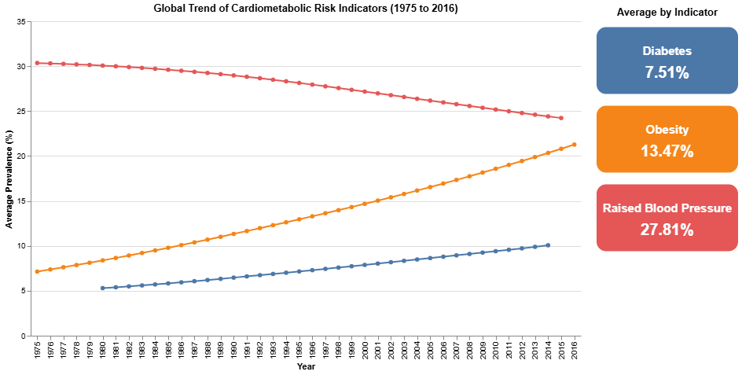
Figure 1. Global trend of cardiometabolic risk indicators
This visual uses an interactive line chart with summary cards to show how the average prevalence of obesity, diabetes, and raised blood pressure changes over time. The line chart is suited to this question because it makes long term direction and relative movement easy to compare, while the indicator-coloured summary cards provide a quick overall reference for average burden across the full period.
The visual immediately shows that the three indicators do not follow the same path. Raised blood pressure remains the highest of the three throughout the period, but its average prevalence declines steadily from just above 30 percent in the mid-1970s to around 24 percent by the end of the series. In contrast, obesity rises strongly across the period, increasing from roughly 7 percent to above 21 percent, while diabetes also rises, though at a lower level, from around 5 percent to about 10 percent. The summary cards reinforce this pattern by showing raised blood pressure as the highest average burden overall, followed by obesity and then diabetes.
This is a strong opening finding because it shows that global cardiometabolic risk is not a single uniform story. One major indicator is falling while two others are rising. This matters because it suggests that progress in one area does not necessarily imply improvement across all related health risks. From a practical perspective, national health planners and prevention programmes should avoid treating cardiometabolic risk as one combined issue with one shared response. In particular, the steady rise in obesity and diabetes suggests a need for earlier preventive action in countries where these indicators are still growing, even if raised blood pressure has improved.

5.1.2 Top 15 countries by prevalence
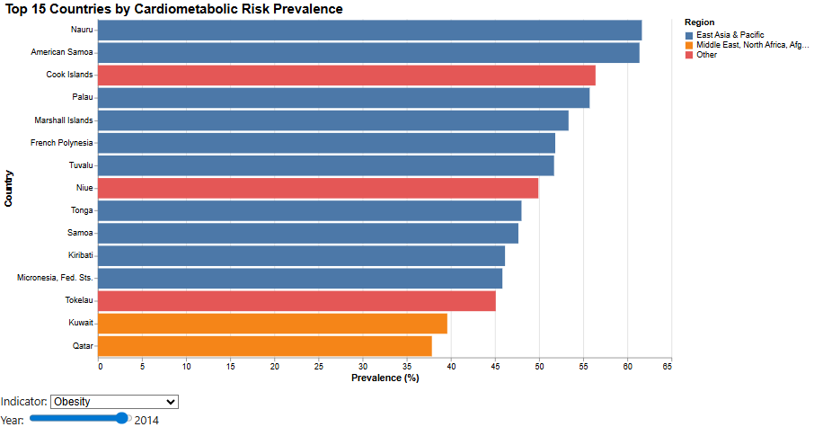
Figure 2. Top 15 countries by prevalence - Obesity
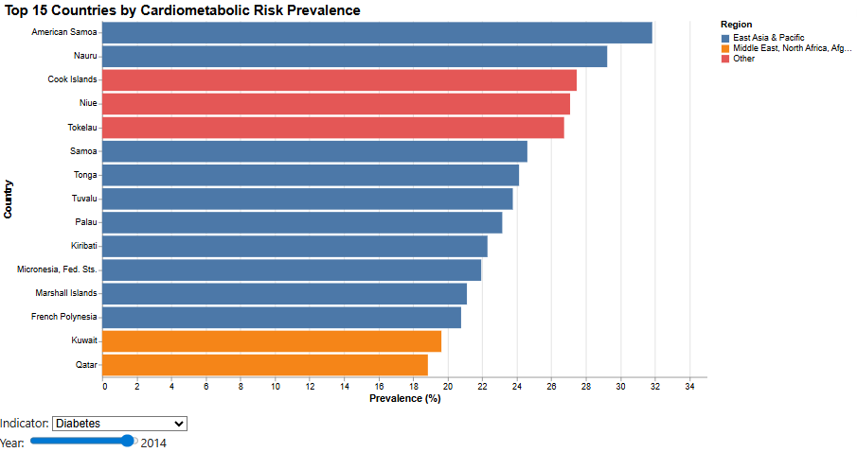
Figure 3. Top 15 countries by prevalence - Diabetes
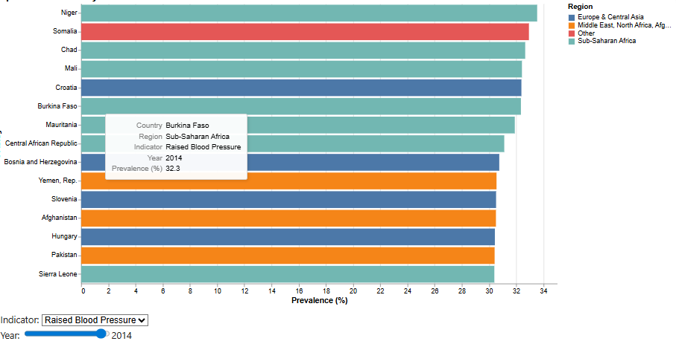
Figure 4. Top 15 countries by prevalence - Raised BP
This visual uses an interactive ranked bar chart to display the top 15 countries for a selected indicator and year. The bar chart is appropriate here because ranked length-based comparison makes the highest prevalence cases immediately visible. The dropdown and year slider also make the view more useful, since the ranking can be changed across indicators and time rather than being fixed to one static snapshot.
The ranking changes clearly depending on the indicator, which is one of the most important findings in the report. For obesity, the highest prevalence levels are dominated by Pacific Island contexts such as Nauru, American Samoa, Cook Islands, Palau, and Marshall Islands, with Kuwait and Qatar also appearing among the highest values. Diabetes shows a similar regional concentration, with American Samoa, Nauru, and several other Pacific locations appearing again near the top. Raised blood pressure, however, follows a very different geography, with several of the highest values concentrated in Sub Saharan African countries such as Niger, Somalia, Chad, Mali, and Burkina Faso.
This visual is significant because it shows that the three indicators do not identify the same countries in the same way. Instead, each indicator highlights a different geography of risk. That strengthens the wider argument of the report by showing that cardiometabolic burden is multidimensional and cannot be reduced to one simple country ranking. The practical implication is that intervention priorities should not be generalised across all cardiometabolic conditions. Countries facing very high obesity or diabetes may need stronger long-term prevention and lifestyle related interventions, while countries with persistently high raised blood pressure may require more immediate screening, monitoring, and treatment focused responses. The main targets affected by this finding are national health authorities, regional public health bodies, and healthcare systems working under different epidemiological pressures.

5.1.3 Country level prevalence trajectories over time
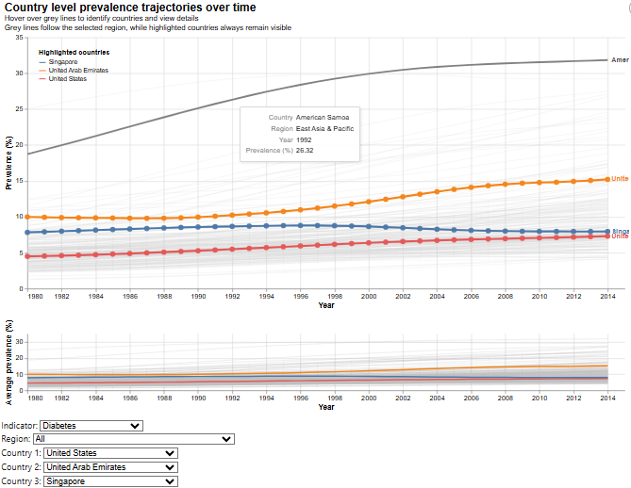
Figure 5. Country level prevalence trajectories over time - Diabetes
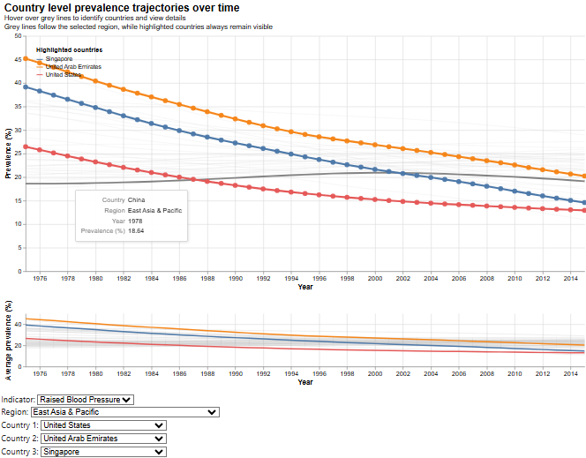
Figure 6. Country level prevalence trajectories over time - Raised BP
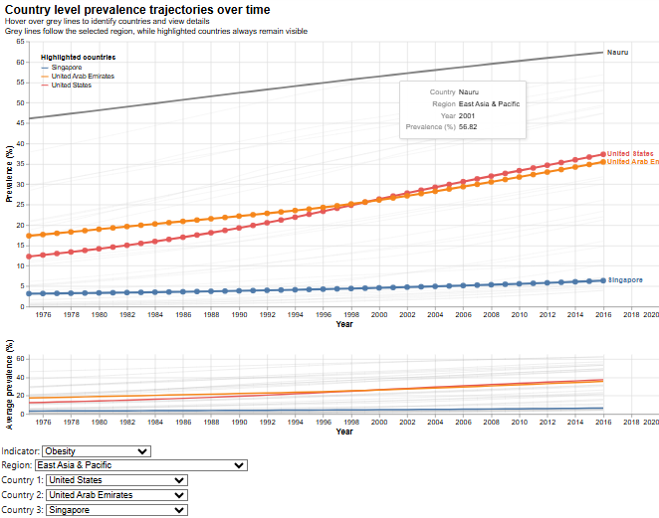
Figure 7. Country level prevalence trajectories over time - Obesity
This visual uses an interactive focus and context line chart to compare selected country trajectories against a wider regional background. The main panel shows individual country lines over time, while the smaller context panel supports year range selection. Dropdown filters allow the reader to switch indicator, region, and highlighted countries, which makes the chart especially useful for comparing country level patterns without losing the wider context.
Across the examples shown, obesity rises clearly in both the United States and the UAE, while Singapore remains much lower despite a gradual increase. Diabetes shows a more moderate upward trend, with the UAE rising steadily, the United States increasing from a lower base, and Singapore remaining comparatively stable. Raised blood pressure shows the opposite direction, with all three highlighted countries declining over time, although they begin from different starting points. The grey background lines are useful because they show that these highlighted countries are part of broader regional patterns rather than isolated cases.
This visual adds depth to the earlier ranking by showing that position in one year does not reveal the full picture. Some countries remain consistently high, some rise gradually, and others improve in one indicator while worsening in another. This matters because it shifts attention from single-year status to long-term change. For policymakers and health planners, it helps identify not only current burden but also emerging future risk, making it more useful than relying only on one-year snapshots.

5.2 Sex Based Differences

5.2.1 Sex differences across indicators over time
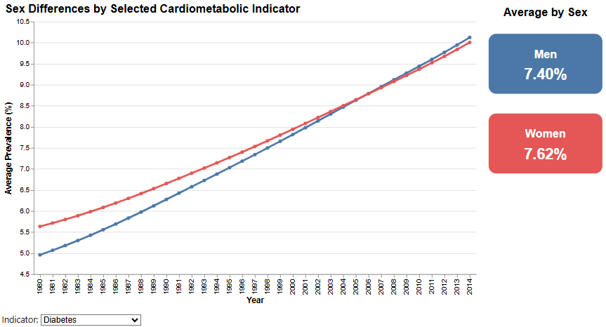
Figure 8. Sex differences across indicators over time - Diabetes
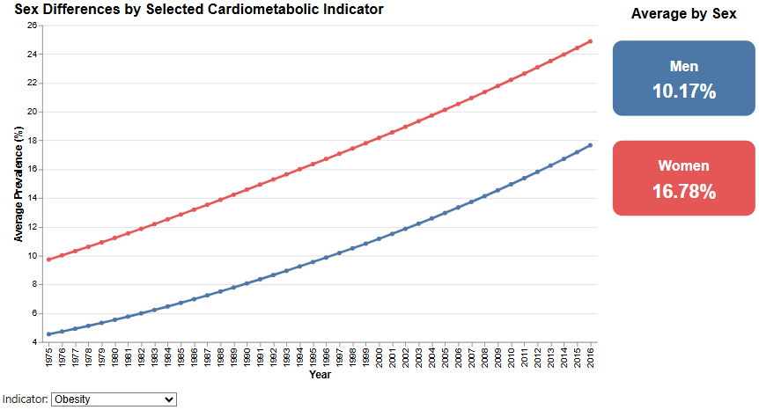
Figure 9. Sex differences across indicators over time - Obesity
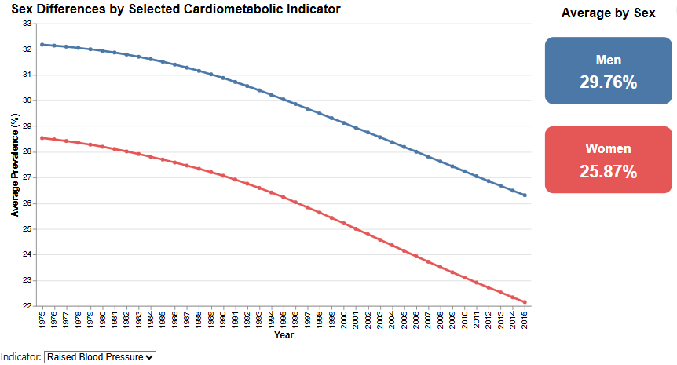
Figure 10. Sex differences across indicators over time - Raised BP
This visual uses an interactive line chart with summary cards to compare average male and female prevalence over time for a selected cardiometabolic indicator. The line chart is suitable here because it shows how the gap between the two groups changes across the full study period, while the dropdown filter allows the reader to switch between obesity, diabetes, and raised blood pressure. The accompanying cards summarise the overall average prevalence for men and women, making the direction and size of the difference easier to interpret.
The visual shows that sex inequality is not consistent across indicators. For diabetes, the two lines remain relatively close throughout the period, with women slightly higher in average, although the gap narrows over time and the two converge by the end of the series. Obesity shows the clearest and most persistent female disadvantage, with women remaining well above men across the full period and the gap staying substantial over time. Raised blood pressure shows the opposite pattern, with men consistently above women even though both groups decline over time. The summary cards reinforce this contrast, showing only a small overall gap for diabetes, a much wider gap for obesity, and a clear male lead for raised blood pressure.
This is an important finding because it shows that sex-based inequality in cardiometabolic health depends strongly on the indicator being examined. Men and women do not face the same pattern of burden across all conditions, so a single general statement about gender risk would be misleading. From a practical perspective, this suggests that prevention and awareness strategies should be designed more selectively. Obesity related interventions may need stronger attention to women in settings where the gap is persistently high, while raised blood pressure screening and early detection may require greater emphasis on men. Diabetes appears more balanced overall, suggesting that broad population level coverage may be more appropriate than strongly sex specific targeting. The main targets affected by this finding are national prevention programmes, primary healthcare systems, and public health planners developing screening and risk reduction strategies.

5.2.2 Gender gap in prevalence across countries
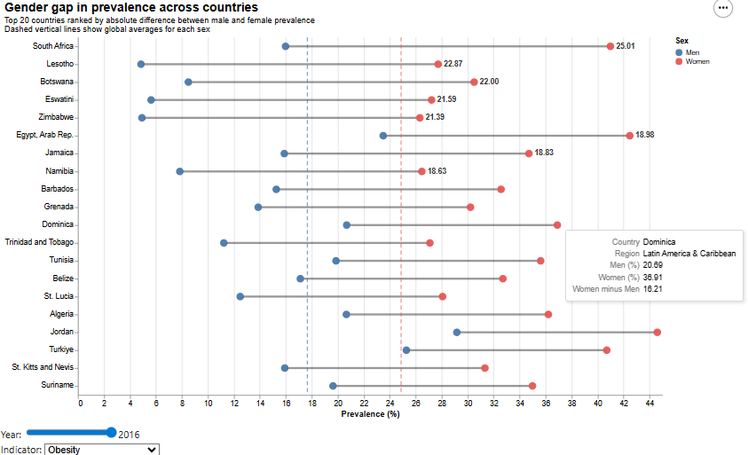
Figure 11. Gender gap in prevalence across countries - Obesity
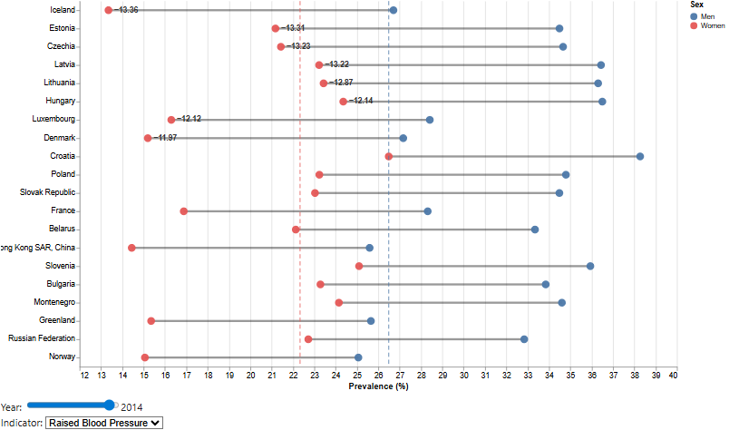
Figure 12. Gender gap in prevalence across countries - Raised BP
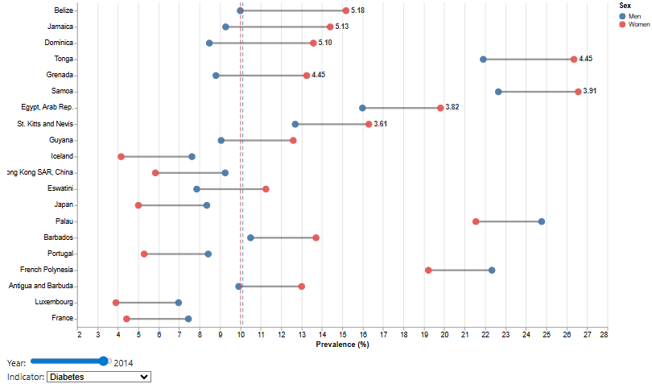
Figure 13. Gender gap in prevalence across countries - Diabetes
This visual uses an interactive dumbbell chart to show the top 20 countries ranked by the absolute difference between male and female prevalence for a selected indicator and year. The dumbbell format is particularly effective because the two endpoints make the size and direction of the sex gap immediately visible, while the connecting line highlights the distance between them more clearly than two separate bars would. The chart also includes an indicator selector and year slider, and the dashed vertical reference lines show the global averages for each sex, helping the reader judge whether a country is extreme relative to the wider pattern.
For obesity, the largest gaps are concentrated in countries where female prevalence is far above male prevalence, including South Africa, Lesotho, Botswana, Eswatini, and Zimbabwe. In several of these cases, the gap is very large, with women exceeding men by more than 15 percentage points. For diabetes, the pattern is more mixed. Some countries such as Belize and Jamaica show higher female values, while others display smaller or more balanced differences. For raised blood pressure, many of the largest gaps run in the opposite direction, with men clearly above women, particularly across several European settings shown in the ranking.
This visual is valuable because average sex differences can hide major country level variation. While the global trend may suggest one overall pattern, the country ranking shows that both the size and direction of the gap can differ sharply across settings. This matters because sex-based policy responses should not be generalised across all countries. Countries with large female obesity gaps may need more targeted prevention strategies, while countries with strong male disadvantages in raised blood pressure may need more focused screening and treatment outreach. This makes the visual relevant for health authorities and prevention programmes that must respond to the type and direction of inequality, not just global averages.

5.3 Regional and Income Inequalities

5.3.1 Regional patterns over time
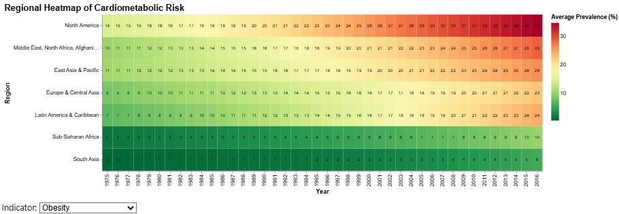
Figure 14. Regional patterns over time - Obesity
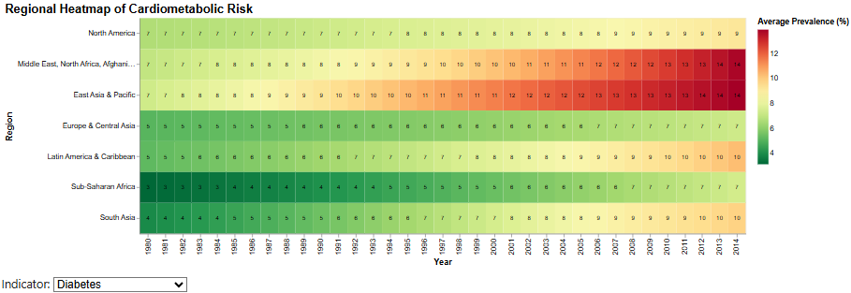
Figure 15. Regional patterns over time - Diabetes
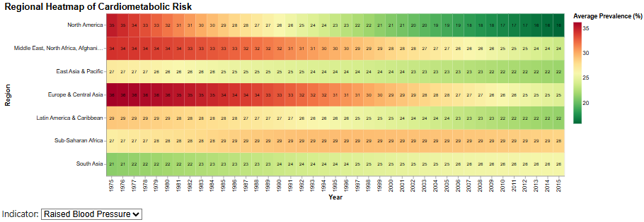
Figure 16. Regional patterns over time - Raised BP
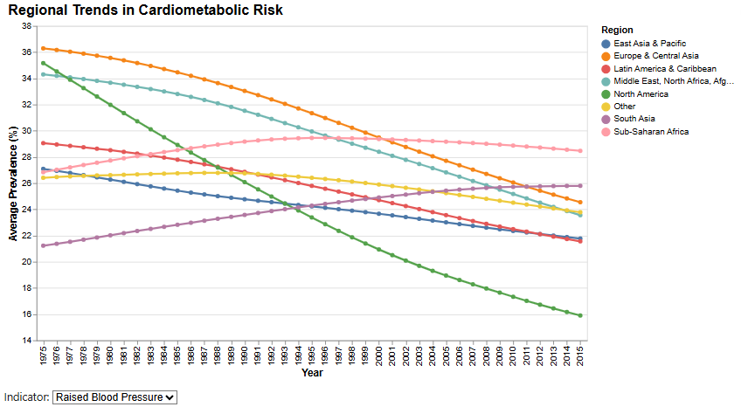
Figure 17. Regional patterns over time - Raised BP Line Version
This visual uses an interactive heatmap to show average prevalence by region across time for a selected indicator. The heatmap is effective here because it allows differences in level and direction to be compared across many years and regions at once, while the indicator dropdown makes it possible to switch between raised blood pressure, obesity, and diabetes without changing the overall layout.
The regional patterns differ clearly by indicator. For raised blood pressure, Europe and Central Asia and North America begin at comparatively high levels and then decline over time, while Sub Saharan Africa remains persistently high with much less improvement. For obesity, the highest levels are concentrated in North America and the Middle East, North Africa, Afghanistan and Pakistan grouping, with strong upward movement visible across most regions over time. For diabetes, the highest values appear in the Middle East, North Africa, Afghanistan and Pakistan grouping, while East Asia and Pacific and South Asia also show clear upward movement across the period.
This visual matters because it shows that regional inequality is not static and not identical across indicators. Some regions face persistently high burden, while others show strong upward momentum. The implication is that regional public health priorities should be indicator specific rather than uniform, with different regional bodies and national health systems likely needing different mixes of prevention, screening, and long-term management.

5.3.2 Distribution by income group and sex
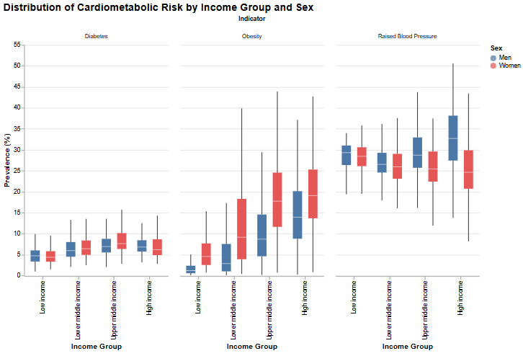
Figure 18. Distribution by income group and sex
This visual uses faceted boxplots to compare the distribution of prevalence across income groups, separately for each indicator and sex. Boxplots are useful here because they show not only central tendency but also spread and variation, making it easier to see whether differences by income group are consistent or widely dispersed.
The pattern varies by indicator. Diabetes shows moderate increases from lower to upper middle-income groups, but with overlapping distributions. Obesity shows a much stronger gradient, with higher prevalence levels and wider spread in upper middle and high-income groups, especially for women. Raised blood pressure shows a different profile, with high values across all income groups and less obvious separation than for obesity, although high income groups still show substantial dispersion, especially for men.
This visual is valuable because it shows that income group differences are not only about averages but also about variability within each category. In other words, countries within the same income group can still have quite different risk profiles. The clearest structural divide appears in obesity, while raised blood pressure remains more broadly distributed across income levels. The implication is that income-based targeting can be useful, especially for obesity, but it should not replace country specific assessment, particularly where within group spread is large.

5.3.3 Income group patterns over time
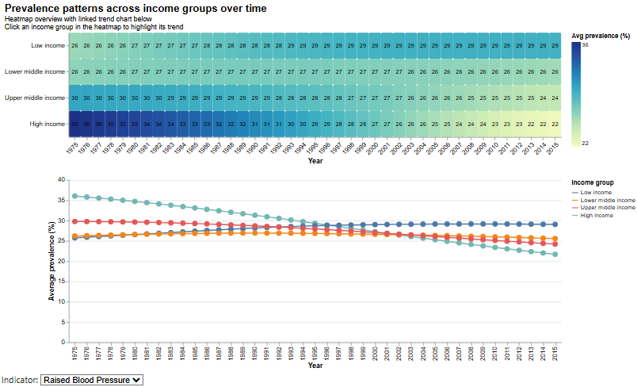
Figure 19. Income group patterns over time - Raised BP
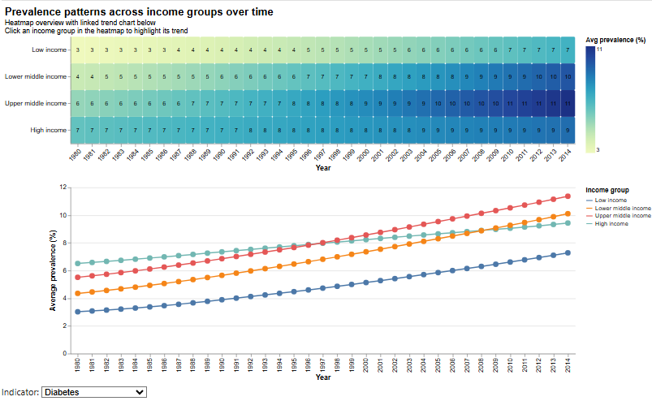
Figure 20. Income group patterns over time - Diabetes
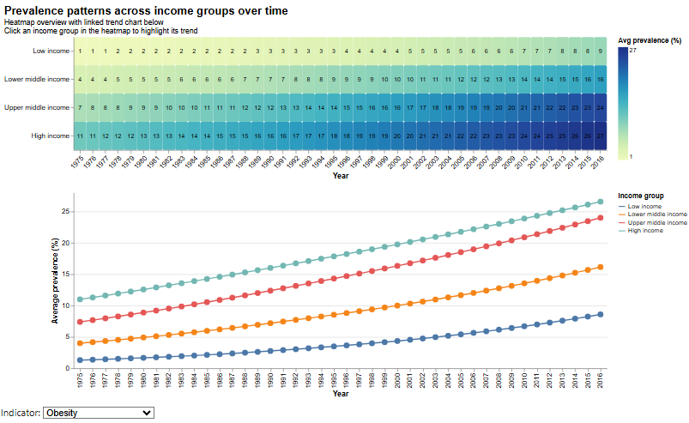
Figure 21. Income group patterns over time - Obesity
This visual uses a linked heatmap and trend chart to show how average prevalence changes across income groups over time for a selected indicator. The heatmap provides a compact overview of relative levels, while the linked line chart shows direction and pace of change more clearly. The interaction is useful because clicking an income group in the heatmap highlights its corresponding trend below, making comparison easier without changing the full layout.
The pattern differs clearly by indicator. For raised blood pressure, high income countries begin with the highest prevalence but decline steadily over time, while low-income countries remain comparatively stable and upper middle-income groups stay persistently elevated. For obesity, all income groups rise, but the gradient is strongest at the upper end, with high income and upper middle-income groups remaining clearly above the rest throughout the period. Diabetes also rises across all groups, though middle and high-income countries show the highest levels by the later years.
This visual adds an important structural insight because it shows that income differences are not only cross sectional but also dynamic. Some gaps narrow, while others remain strong or widen depending on the indicator. The main implication is that income group still matters for interpreting burden, but the direction of change is equally important for identifying where future pressure may grow.

5.3.4 Regional ranking over time
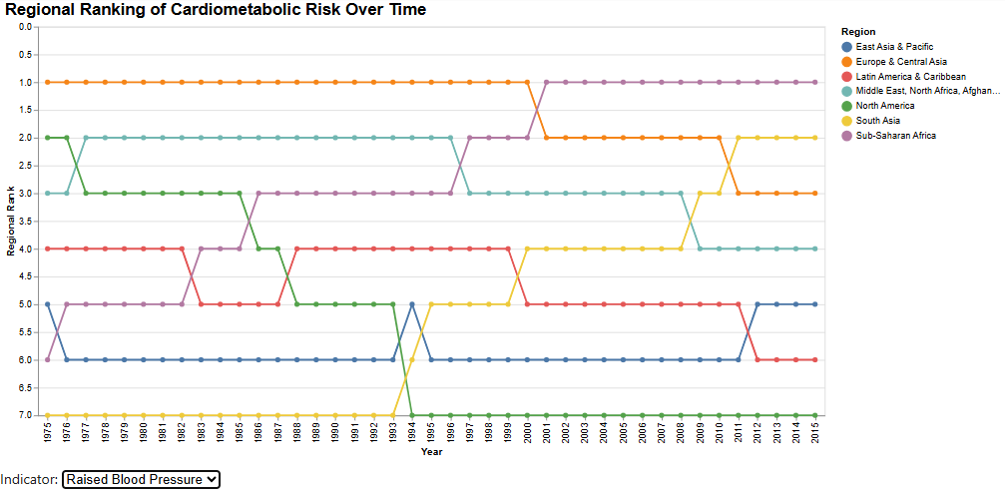
Figure 22. Regional ranking over time - Raised BP
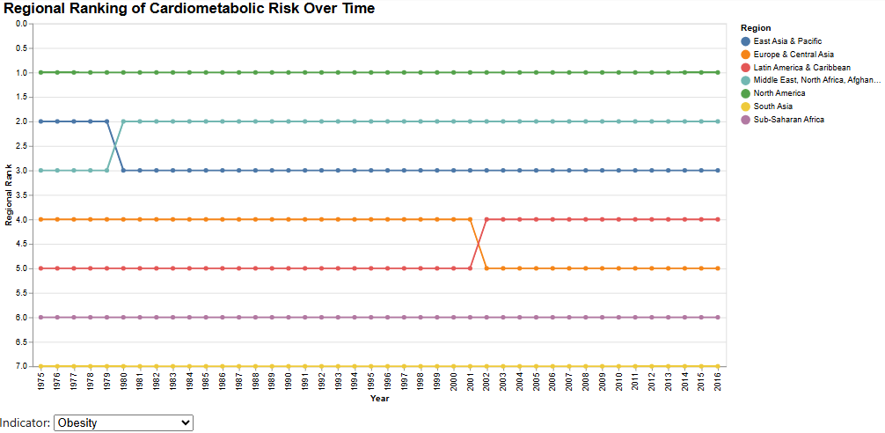
Figure 23. Regional ranking over time - Obesity
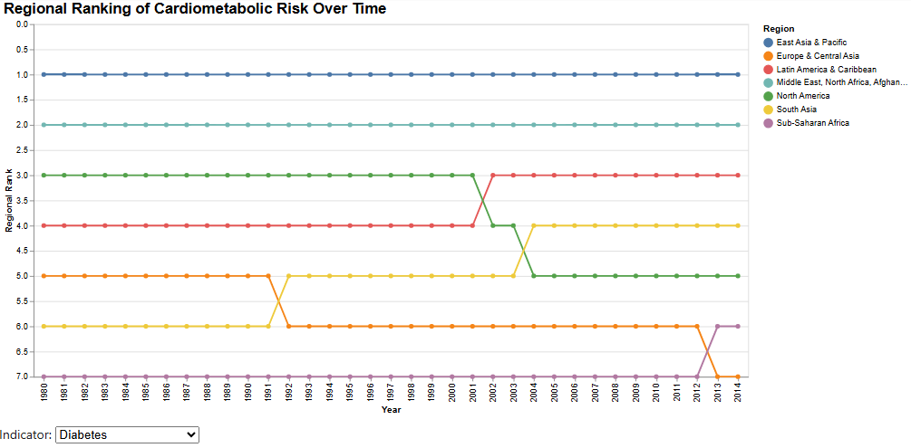
Figure 24. Regional ranking over time - Diabetes
This visual uses an interactive rank line chart to compare how regions move relative to one another over time for a selected indicator. The rank-based design is effective because it simplifies comparison by focusing on relative position rather than absolute value, making it easier to see whether the regional ordering stays stable or changes across the years.
For obesity, the ranking is highly stable, with North America remaining first throughout the full period and South Asia remaining last, while other regions shift only slightly. Diabetes is similarly stable, with East Asia and Pacific and the Middle East, North Africa, Afghanistan and Pakistan grouping remaining near the top, while Europe and Central Asia and Sub-Saharan Africa remain lower ranked. Raised blood pressure shows more movement, with Europe and Central Asia and North America starting near the top but Sub-Saharan Africa rising into the highest rank later in the series while North America falls to a lower position.
This visual matters because it shows that some regional inequalities are deeply persistent, while others shift over time. In practical terms, stable high ranking suggests entrenched burden, while upward movement suggests worsening relative risk. This makes the chart useful for regional comparison and for identifying where long-term monitoring or more targeted policy attention may be needed.

5.4 Socioeconomic Relationships and Explanatory Context

5.4.1 Economic development and cardiometabolic risk
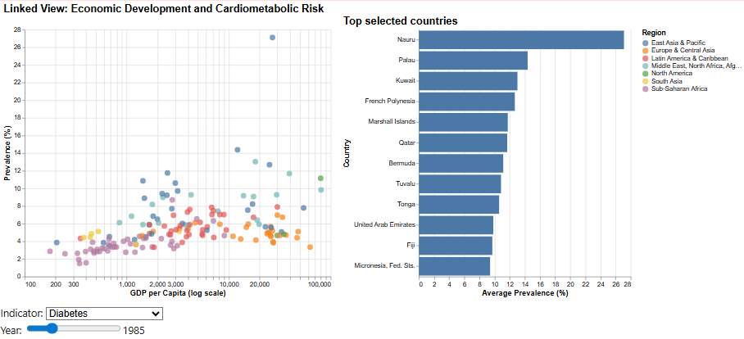
Figure 25. Economic development and cardiometabolic risk – Diabetes (Previously)
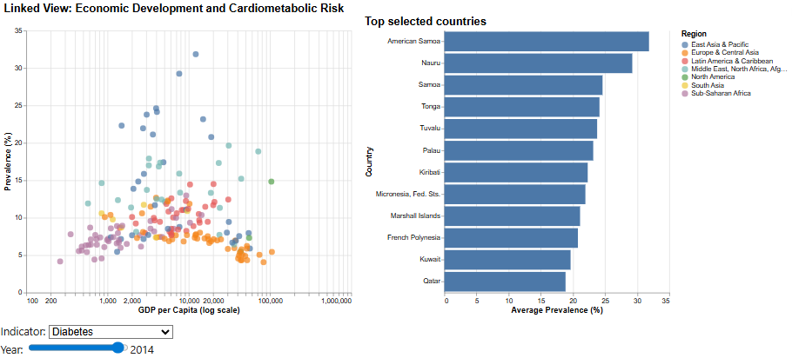
Figure 26. Economic development and cardiometabolic risk - Diabetes (Now)
This visual uses a linked scatter plot and ranked bar chart to compare prevalence against Gross Domestic Product per capita for a selected indicator and year. The scatter plot is useful for showing the broad relationship across countries, while the linked bar chart makes it easier to inspect the highest prevalence cases within the selected range.
The pattern shown for diabetes is not strongly linear. Higher income countries do not always record the highest prevalence, and several of the top cases come from small island contexts such as American Samoa, Nauru, Samoa, and Tonga rather than from the richest economies alone. This suggests that economic development by itself does not explain cardiometabolic burden in a simple way. The relationship appears more uneven, with some middle and upper-income settings showing particularly high prevalence despite very different income levels.
This matters because it shows that national wealth alone is not a reliable proxy for health risk. Countries with moderate or high income may still carry substantial burden, so policymakers should interpret economic development as contextual rather than protective on its own.

5.4.2 Urbanisation and obesity
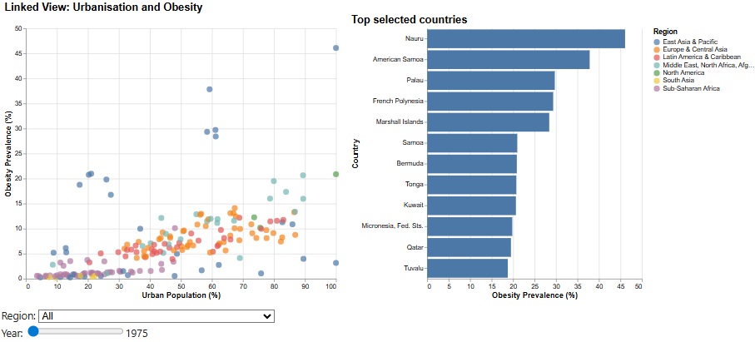
Figure 27. Urbanisation and obesity - Previously
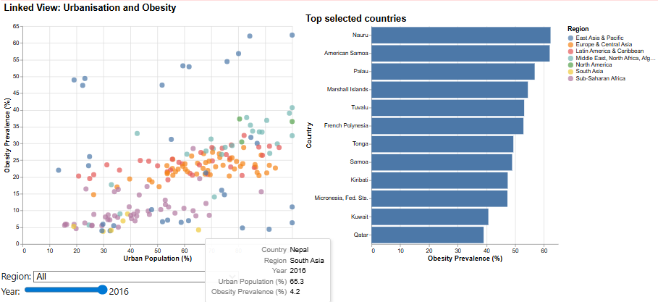
Figure 28. Urbanisation and obesity - Now
This visual uses a linked scatter plot and ranked bar chart to examine obesity against urban population share. The region filter and year slider allow comparison across time and geographic context, while the linked bars identify the highest prevalence countries inside the selected view.
The scatter shows a broadly positive relationship, with obesity tending to rise as urbanisation increases. This pattern is especially clear in the later year view, where many of the highest obesity values appear among highly urbanised countries. At the same time, the spread of points shows that urbanisation is not the only factor involved, since countries with similar urban shares can still have very different obesity levels. The linked ranking reinforces the concentration of high obesity in Pacific Island settings and Gulf countries.
The main implication is that urbanisation appears to be an important contextual factor for obesity, but not a complete explanation. Countries undergoing rapid urban transition may therefore need stronger prevention efforts before high obesity levels become more entrenched.

5.4.3 Ageing population and raised blood pressure
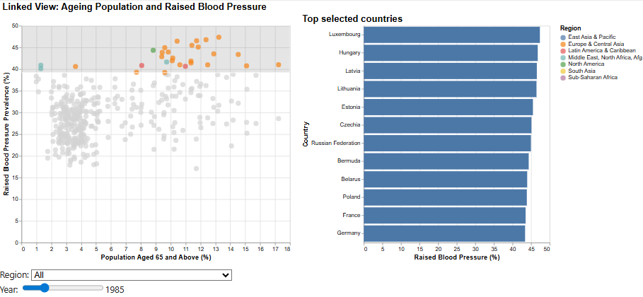
Figure 29. Ageing population and raised blood pressure - Previously
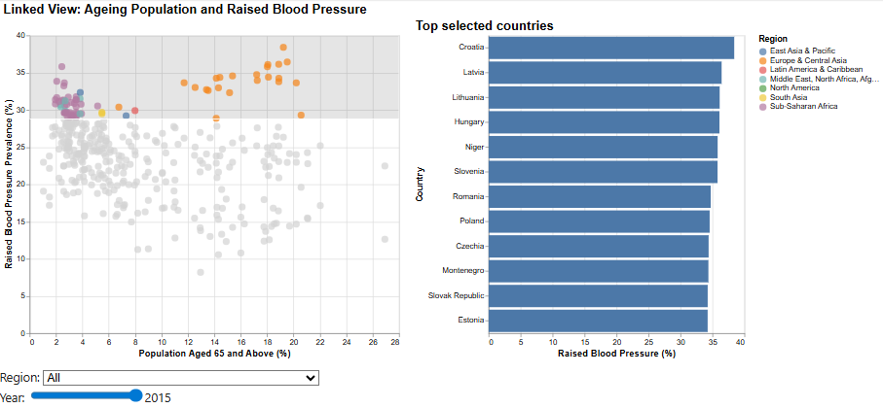
Figure 30. Ageing population and raised blood pressure - Now
This visual uses a linked scatter plot and ranked bar chart to compare raised blood pressure with the share of population aged 65 and above. The chart is helpful because it shows whether older population structure aligns with higher blood pressure prevalence and allows the highest burden countries in the selected view to be identified quickly.
The relationship is visible but not simple. Many of the highlighted high prevalence countries have older population shares in the middle to upper range, especially in the earlier view, but there is also substantial spread among countries with similar ageing levels. In the later view, some countries with relatively modest ageing still show high blood pressure prevalence, which suggests that age structure alone does not determine the pattern.
This visual matters because it shows that ageing contributes useful context but should not be treated as a full explanation. Health systems in older societies may need sustained blood pressure screening, but countries with younger populations cannot be assumed to be low risk.

5.4.4 Urbanisation, obesity, & gender patterns across selected countries
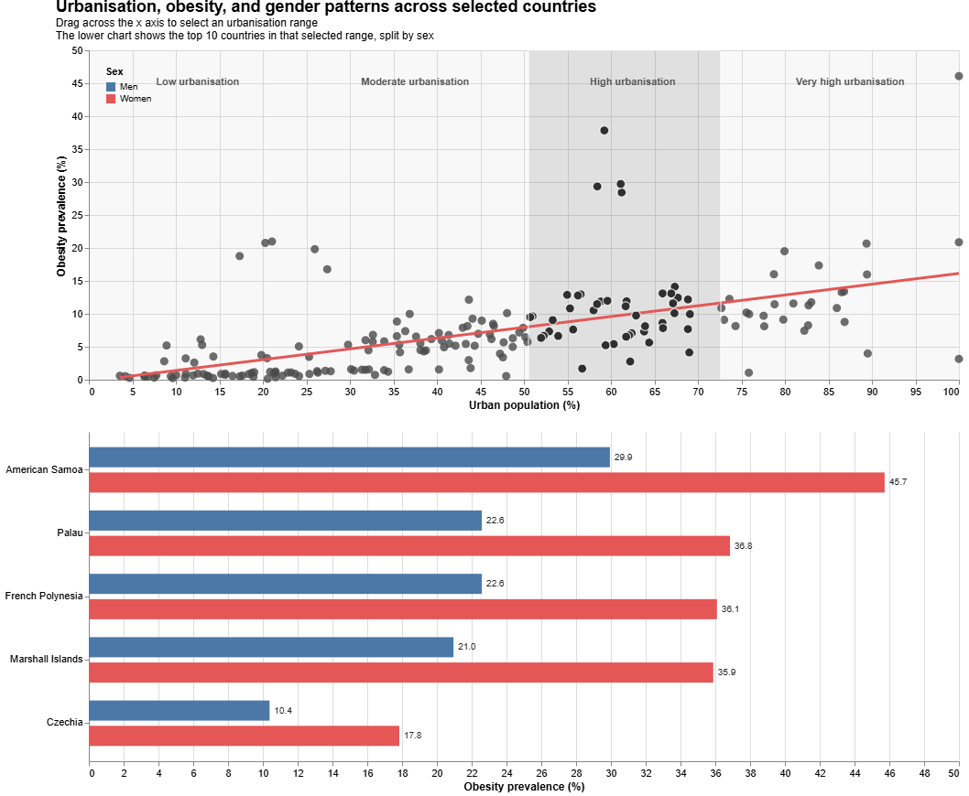
Figure 31. Urbanisation, obesity, & gender patterns - Previously

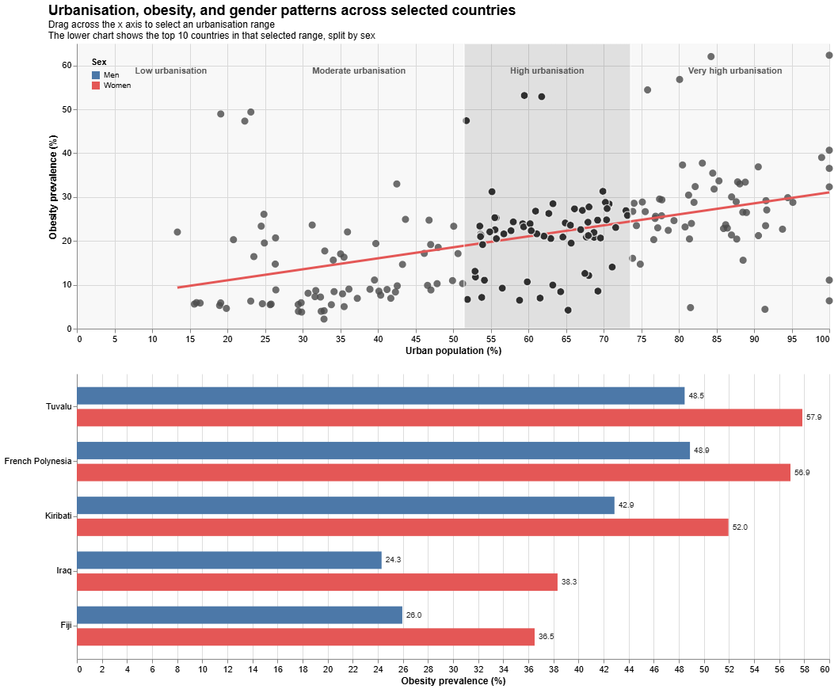
Figure 32. Urbanisation, obesity, & gender patterns - Now
This visual uses a brushed scatter plot linked to grouped gender split bars. The upper panel shows obesity against urban population share with a fitted trend line, and the lower panel shows the top countries within the selected urbanisation range separated by men and women. This is one of the richer views in the report because it combines relationship analysis, interaction, ranking, and gender comparison in one layout.
The chart again shows a positive overall association between urbanisation and obesity, but the lower bars reveal that the pattern is not gender neutral. In the selected high burden countries, women often record clearly higher obesity prevalence than men. This is especially visible in Pacific Island settings and in some Middle Eastern contexts, where the female values are markedly above the male values. Another visible trend is the rise of urbanisation and obesity over the years.
This visual is useful because it connects three parts of the story at once: urban context, national obesity burden, and gender inequality. The main implication is that obesity prevention in highly urbanised settings may need more targeted approaches, especially where the burden is concentrated among women rather than distributed evenly across the population.

5.4.5 Economic development, ageing, and cardiometabolic risk
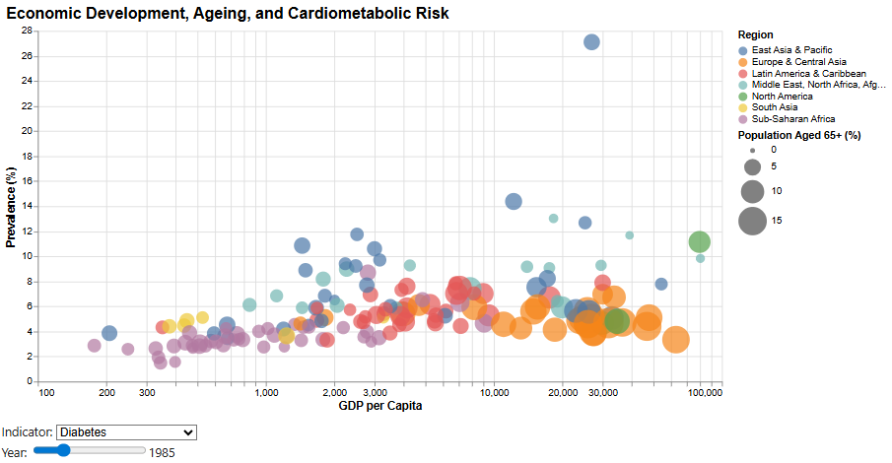
Figure 33. Economic development, ageing, and cardiometabolic risk - Previously
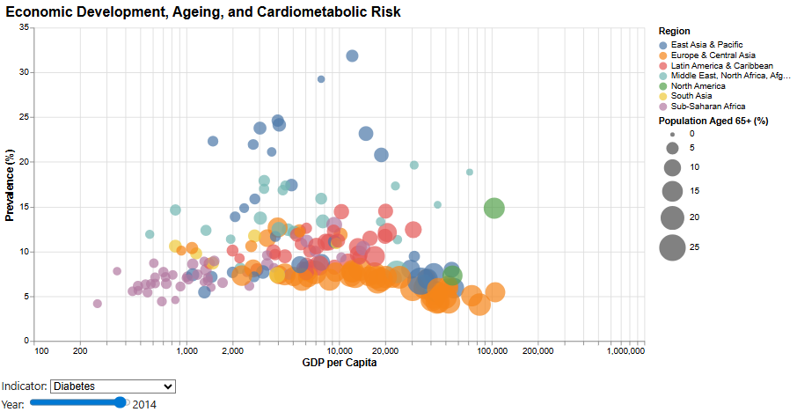
Figure 34. Economic development, ageing, and cardiometabolic risk - Now
This visual uses an interactive bubble chart to compare Gross Domestic Product per capita with prevalence, while encoding population aged 65 and above through bubble size and region through colour. This makes it useful for examining several contextual dimensions at once without splitting the view into separate charts. The year slider and indicator selector also allow the same structure to be explored across different conditions and time points.
In the diabetes examples shown, the pattern remains uneven rather than strongly linear. Several of the highest prevalence values appear in countries with moderate or upper middle levels of economic development rather than only in the richest settings. Larger bubbles are more common at higher income levels, reflecting older population structures, but high diabetes prevalence is not limited to the oldest societies. This suggests that ageing and economic development add useful context, but they do not produce a simple single pathway of risk.
The value of this visual is that it shows how multiple contextual factors can overlap without fully determining the outcome. Countries with similar income levels can still differ sharply in prevalence, and older populations do not always correspond to the highest burden.

5.4.6 Health expenditure, prevalence, and sex differences
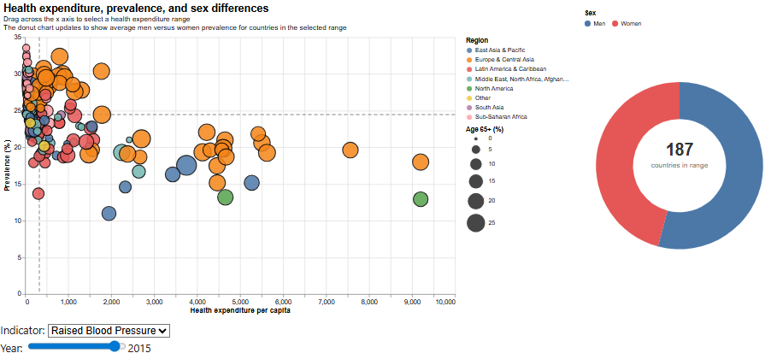
Figure 35. Health expenditure, prevalence, and sex differences - Raised BP
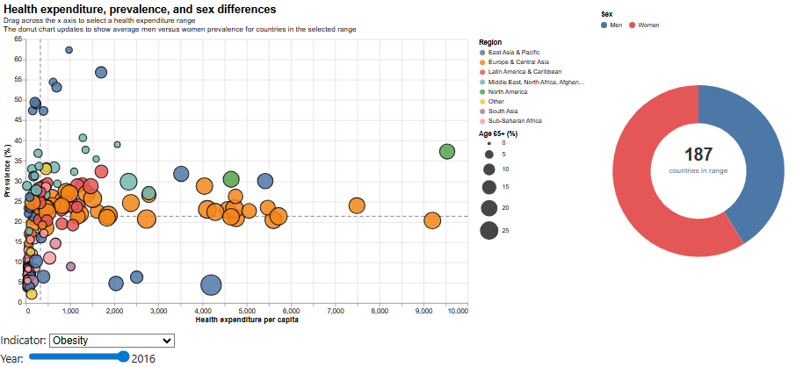
Figure 36. Health expenditure, prevalence, and sex differences - Obesity
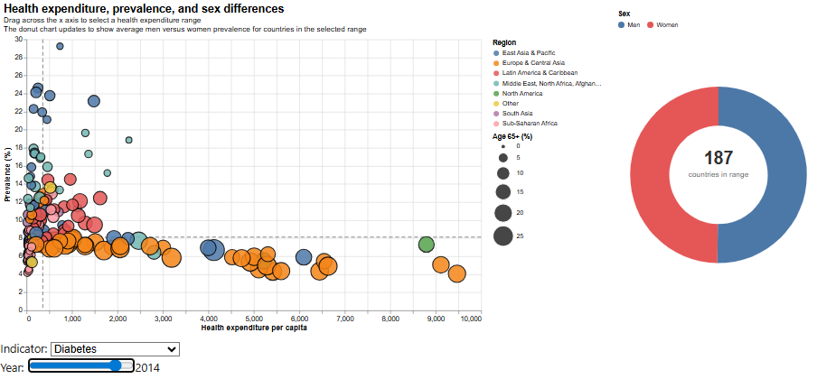
Figure 37. Health expenditure, prevalence, and sex differences - Diabetes
This visual uses an interactive bubble chart linked to a donut chart. The scatter panel compares average prevalence with health expenditure per capita, while bubble size represents ageing population share and colour identifies region. Brushing across the x axis selects a health expenditure range, and the donut chart then updates to show the average prevalence split between men and women for countries within that selected range.
The overall pattern suggests that higher health expenditure does not automatically correspond to lower cardiometabolic burden. For obesity and raised blood pressure, high prevalence values remain visible across a wide range of spending levels. For diabetes, some of the higher prevalence cases appear at lower to middle spending levels, while several higher spending countries show more moderate values. The donut summaries also show that gender differences remain present within selected expenditure ranges, particularly for obesity, where women account for a larger share of the average burden in the illustrated example.
This visual is useful because it shows that spending level alone cannot be treated as a simple solution indicator. Health expenditure matters, but burden can remain high even in higher spending settings, which suggests that the effectiveness, targeting, and broader context of health systems are also important.

5.4.7 Correlation between cardiometabolic risk and socioeconomic factors
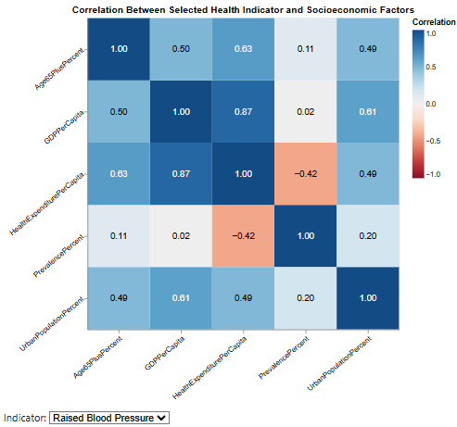
Figure 38. Correlation between cardiometabolic risk and socioeconomic factors – Raised BP
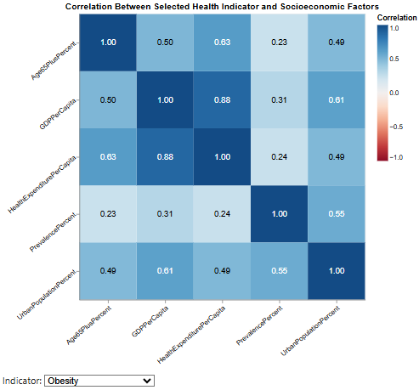
Figure 39. Correlation between cardiometabolic risk and socioeconomic factors - Obesity
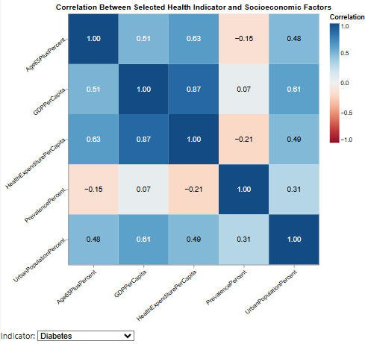
Figure 40. Correlation between cardiometabolic risk and socioeconomic factors - Diabetes
This visual uses an interactive correlation heatmap to summarise how each selected indicator relates to the socioeconomic variables in the enriched dataset. The indicator dropdown makes it possible to switch between raised blood pressure, obesity, and diabetes, which is useful because it allows the strength and direction of association to be compared across conditions within the same format.
The matrix shows that the relationship between prevalence and socioeconomic context differs by indicator. For obesity, prevalence has a moderate positive correlation with urban population percentage and a smaller positive relationship with Gross Domestic Product per capita and health expenditure per capita. This supports the earlier scatter plots, which suggested that obesity is more closely tied to urban and higher income settings than the other indicators. Raised blood pressure shows only a very weak positive relationship with age structure and almost no relationship with Gross Domestic Product per capita, while its association with health expenditure is moderately negative. Diabetes shows a weak negative relationship with age 65 plus share and health expenditure, and only a small positive relationship with urban population percentage.
This visual is useful because it acts as a synthesis of the relationship-based analysis rather than a replacement for it. It confirms that obesity has the clearest positive association with urban and development related factors, while diabetes and raised blood pressure show weaker or mixed patterns.

5.4.8 Countries with the fastest rise in prevalence
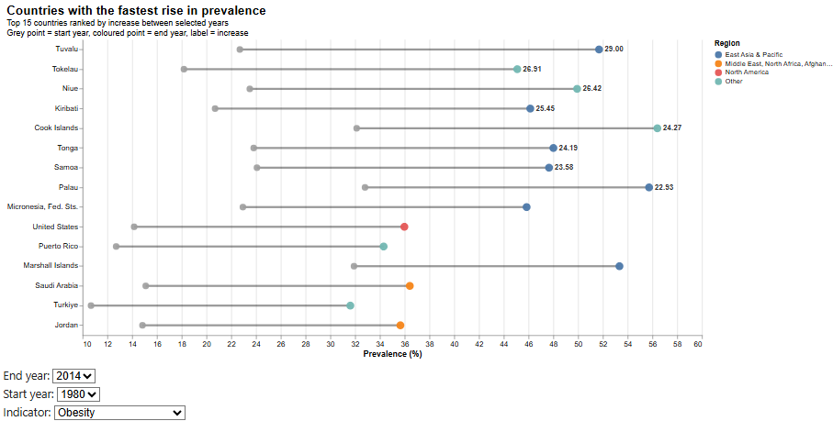
Figure 41. Countries with the fastest rise in prevalence - Obesity
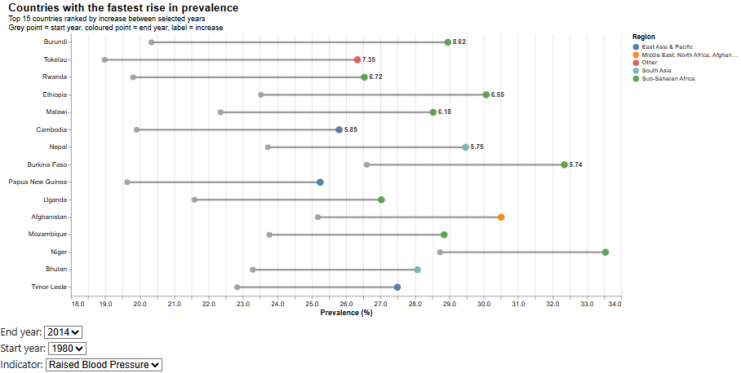
Figure 42. Countries with the fastest rise in prevalence - Raise BP
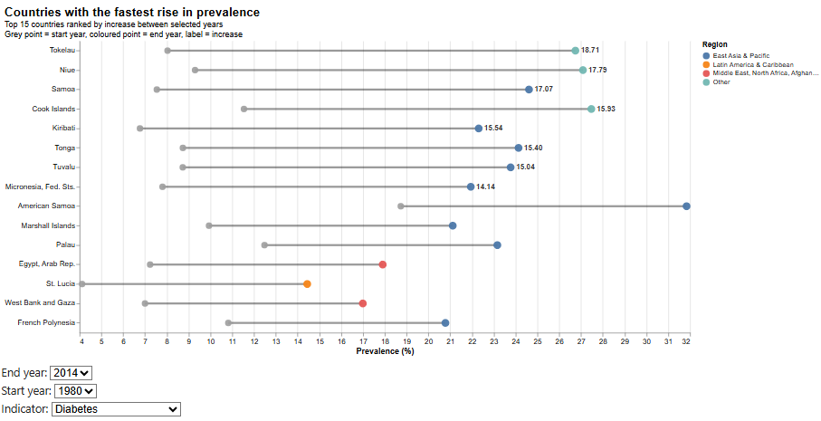
Figure 43. Countries with the fastest rise in prevalence - Diabetes
This visual uses an interactive ranked lollipop chart to show the countries with the largest increase in prevalence between a selected start year and end year. The grey point marks the starting value, the coloured points according to the region shows the ending value, and the connecting line makes the size of the increase easy to compare. The indicator selector and year selectors are especially useful here because they allow the ranking of fastest rising countries to be tested across different conditions and time windows rather than being fixed to one comparison.
The obesity view shows the strongest and most concentrated increases. Several Pacific Island settings such as Tuvalu, Tokelau, Niue, Kiribati, Cook Islands, Tonga, Samoa, and Palau dominate the ranking, with very large increases over the selected period. This reinforces the earlier country ranking visuals and confirms that these countries are not only high burden cases but also among the fastest worsening. Diabetes shows a similar concentration in Pacific settings, including Tokelau, Niue, Samoa, Cook Islands, and Kiribati, although the scale of increase is smaller than for obesity. Raised blood pressure follows a different pattern, with several Sub-Saharan African countries such as Burundi, Rwanda, Ethiopia, Malawi, and Mozambique appearing among the fastest increases, alongside a few countries from other regions.
This visual is important because it shifts the analysis from current level to rate of change. A country may not yet be the single highest burden case, but a rapid increase still signals growing future pressure. It also shows again that the geography of worsening differs by indicator, which means that the countries requiring urgent attention are not the same across all forms of cardiometabolic risk. The practical implication is that health planners should monitor both burden and momentum. Countries with the steepest rises may need earlier intervention, stronger surveillance, and more targeted prevention before these trends become even harder to reverse.

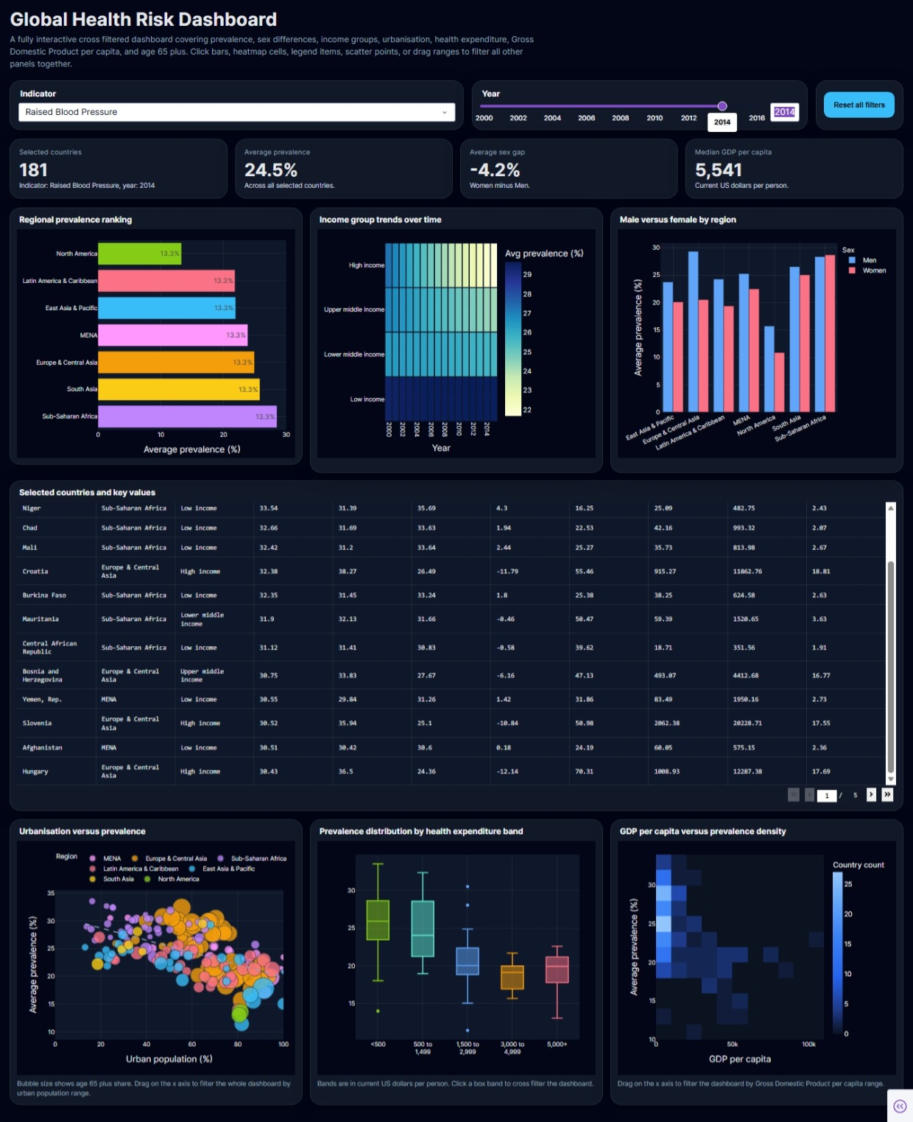
6. Dashboard Discussion
Figure 44. Dashboard

6.1 Dashboard Purpose and Structure
The final dashboard was designed as a central interactive interface that brings together the main analytical dimensions of the report in one place. Its purpose is not simply to display multiple charts, but to allow the user to move across regional comparison, income group patterns, gender differences, urbanisation, health expenditure, and Gross Domestic Product per capita within a single coordinated view. This is important because the report has shown that cardiometabolic risk cannot be understood through one chart or one variable alone. A dashboard format makes it possible to connect these perspectives more effectively.
The final dashboard includes a top-level indicator selector and year slider, followed by headline summary cards and a set of linked panels covering regional prevalence ranking, income group trends, male versus female comparison by region, a selected countries table, urbanisation versus prevalence, prevalence by health expenditure band, and Gross Domestic Product per capita versus prevalence density. This layout supports both overview and detail. The top of the dashboard provides rapid summary, while the lower panels and country table allow closer inspection of the selected subset.

6.2 Interaction and Filtering
A major strength of the dashboard is its use of cross filtering. Users can change the indicator and year globally, but they can also interact directly with charts to refine the analysis further. Clicking bars, heatmap cells, legend items, scatter points, or expenditure bands updates the rest of the interface, allowing patterns to be explored from multiple starting points. This is especially useful because it reduces the need to create separate static charts for every combination of variables.
The dashboard therefore supports deeper exploration than a single fixed visual. A user can begin from regional burden, then move to sex comparison, then inspect the selected countries and their contextual variables, all within the same view. This improves usability because it helps the reader ask to follow up questions rather than just observe a prepared result. It also aligns well with the goals of the project, since filtering and linked views make the analysis more interactive, more targeted, and easier to interpret.

6.3 From the Altair Dashboard to the Final Dash Dashboard
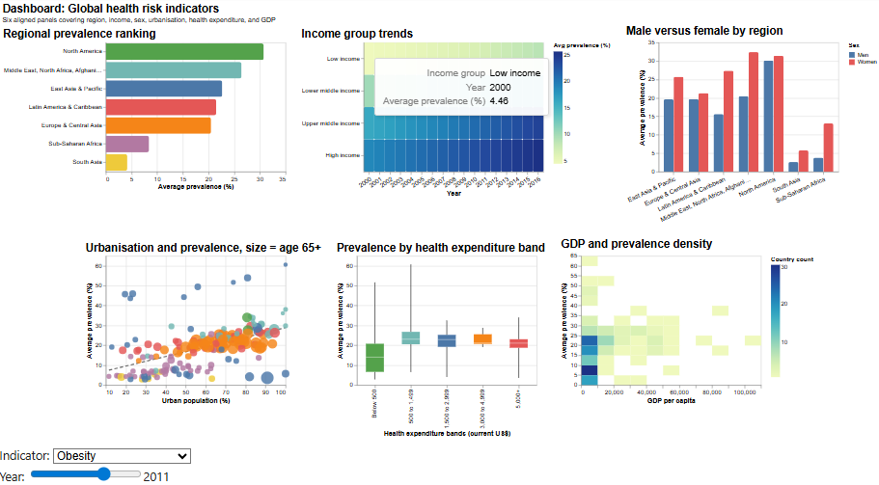
Figure 45. Old Altair Dashboard
An earlier dashboard version was also developed in Altair. That version was useful as a proof of concept because it showed that the main analytical components could be combined into one visual layout. It already included six broad views covering region, income, sex, urbanisation, health expenditure, and Gross Domestic Product per capita. However, it was more limited in both appearance and interaction. The layout was less polished, the information density was lower, and the cross-filtering behaviour was not as strong or as seamless as required for a final submission.
For these reasons, the final dashboard was implemented in Dash. This made it possible to produce a more cohesive and visually stronger interface with better control over styling, layout, summary cards, reset behaviour, and linked interactions across panels. The final version is therefore more suitable as the report’s main dashboard because it supports clearer navigation, stronger visual consistency, and a more complete exploration experience. In that sense, the Altair dashboard served as an important intermediate design step, while the Dash dashboard became the final analytical product.

6.4 Overall Value of the Dashboard
The dashboard adds value to the report by turning the analysis into something exploratory rather than purely static. It allows the user to compare patterns across several dimensions at once and helps reveal how the same indicator can look different depending on region, income group, sex, or development context. This makes it especially useful for decision makers who may want both a quick summary and the ability to inspect specific cases.
Overall, the final dashboard strengthens the report by functioning as a centralised, interactive summary of the wider analysis. It supports the report’s main argument that cardiometabolic risk is multidimensional and that effective visual analytics should allow readers to move between overview, comparison, and detail with ease.

7. Conclusion
This report set out to explore how obesity, diabetes, and raised blood pressure vary across countries and over time, and how these patterns relate to broader demographic and socioeconomic context. Starting from the original coursework dataset, the analysis enriched the health data with Gross Domestic Product per capita, health expenditure per capita, urban population percentage, population aged 65 years and above percentage, and World Bank income group and regional classifications. This made it possible to move beyond simple prevalence comparison and develop a broader visual analysis of global cardiometabolic inequality.
Several important findings emerged. First, the three indicators did not follow the same long-term pattern. Raised blood pressure remained the highest overall burden but declined over time, while obesity and diabetes both increased, with obesity showing the sharpest rise. Second, country level analysis showed that the geography of high burden differs by indicator. Pacific island settings were repeatedly prominent in obesity and diabetes, while raised blood pressure showed a different concentration, especially in parts of Sub-Saharan Africa. Third, sex differences were substantial but not uniform. Women showed clearly higher obesity prevalence in many contexts, while men remained more affected by raised blood pressure, and diabetes was comparatively more balanced. Fourth, regional and income group analysis showed that inequality is persistent but also dynamic, with some gradients remaining stable and others shifting over time. Finally, the socioeconomic analysis showed that variables such as urbanisation, ageing, health expenditure, and economic development do matter, but none of them alone provides a complete explanation of prevalence patterns.
Taken together, these findings suggest that cardiometabolic risk should not be interpreted as a single combined problem with one shared geography or one shared policy response. The burden differs by indicator, by sex, by country, and by structural context. This means that intervention priorities should be more targeted. Countries with rapidly rising obesity or diabetes may need earlier prevention and lifestyle focused action, while countries with persistently high raised blood pressure may require stronger screening, treatment, and long-term management strategies. Likewise, regional and sex-based inequalities indicate that broad global averages are not enough for practical decision making.
The report also demonstrates the value of careful data preparation and visual design. By restructuring the original health sheets, creating derived variables, enriching the dataset with external sources, and using a varied set of visual forms, the analysis was able to reveal patterns that would have been difficult to communicate through raw tables alone. The final interactive dashboard extended this further by allowing linked exploration across region, income group, sex, urbanisation, health expenditure, and Gross Domestic Product per capita. Overall, the project shows that well prepared tabular data and thoughtful visual analytics can provide a more nuanced and actionable understanding of global health risk than isolated prevalence figures alone.

References
World Bank. n.d. GDP per capita (constant 2015 US$). World Development Indicators. Available at: https://data.worldbank.org/indicator/NY.GDP.PCAP.KD (Accessed: 15 March 2026).
World Bank. n.d. Current health expenditure per capita (current US$). World Development Indicators. Available at: https://data.worldbank.org/indicator/SH.XPD.CHEX.PC.CD (Accessed: 15 March 2026).
World Bank. n.d. Urban population (% of total population). World Development Indicators. Available at: https://data.worldbank.org/indicator/SP.URB.TOTL.IN.ZS (Accessed: 15 March 2026).
World Bank. n.d. Population ages 65 and above (% of total population). World Development Indicators. Available at: https://data.worldbank.org/indicator/SP.POP.65UP.TO.ZS (Accessed: 15 March 2026).
The World Bank Data n.d. World Bank Country and Lending Groups. Available at: https://datahelpdesk.worldbank.org/knowledgebase/articles/906519-world-bank-country-and-lending-groups (Accessed: 15 March 2026).

Appendix
Screenshots of few examples for chart/dashboard interactions.
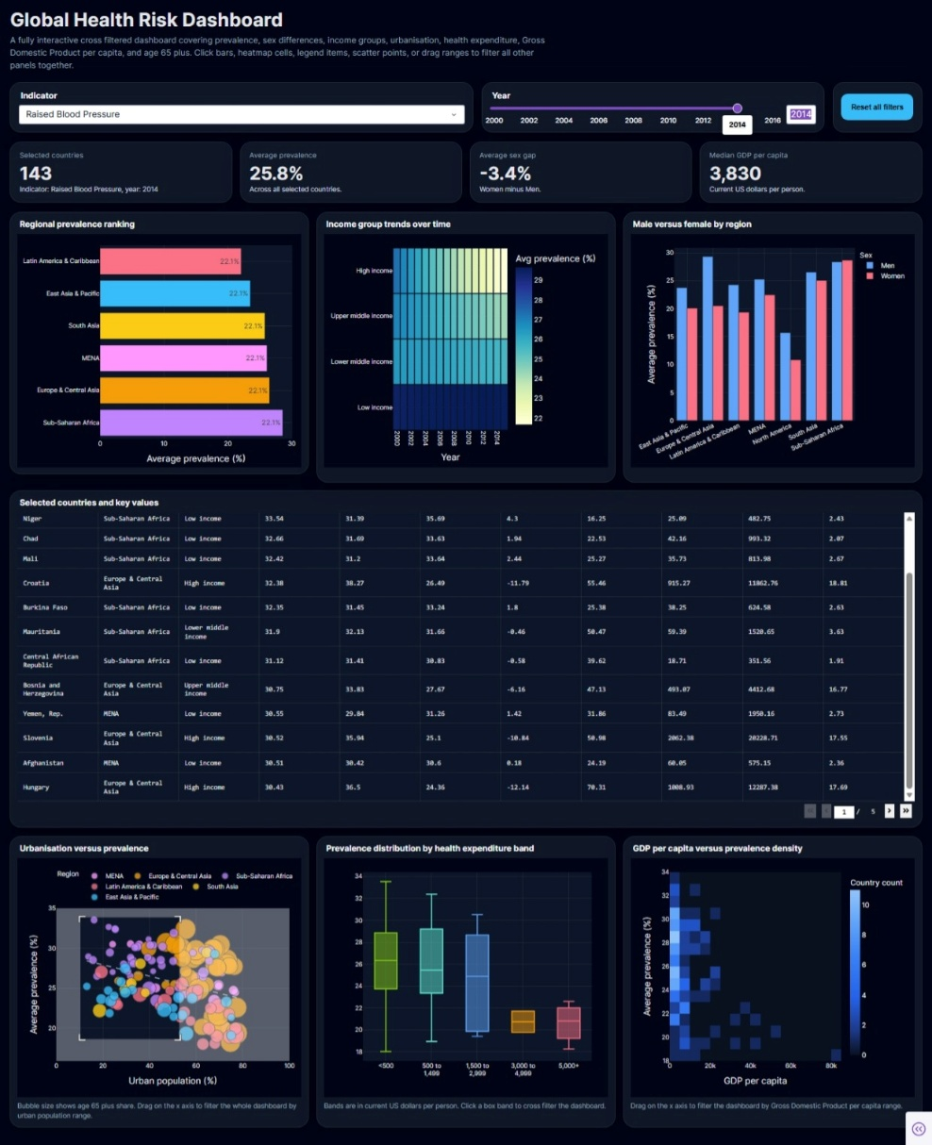
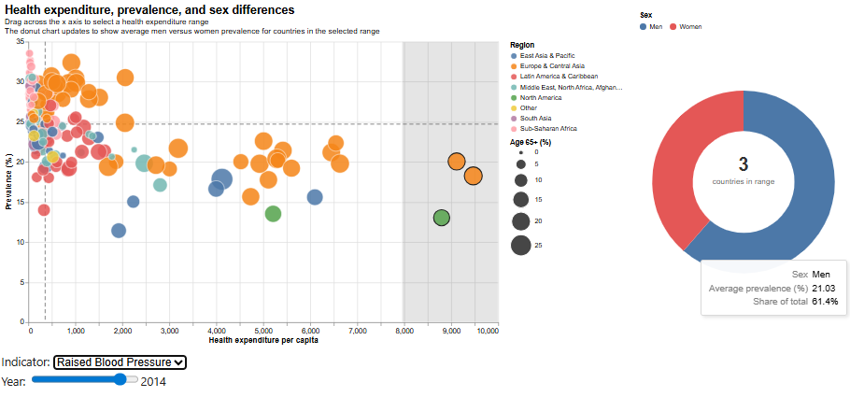
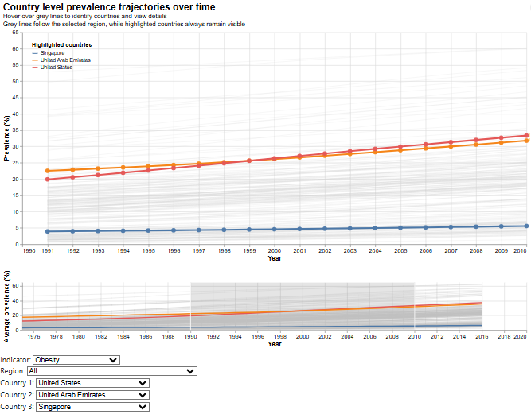
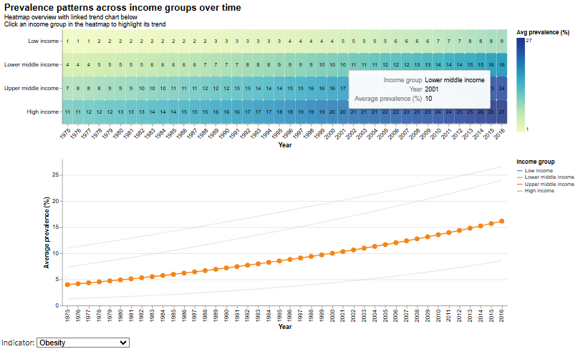
Final Dataset table:

